ELECTRICITY PRICE PREDICTION

PHASE 3 SUBMISSION DOCUMENT

PHASE 3: DEVELOPMENT PART 1

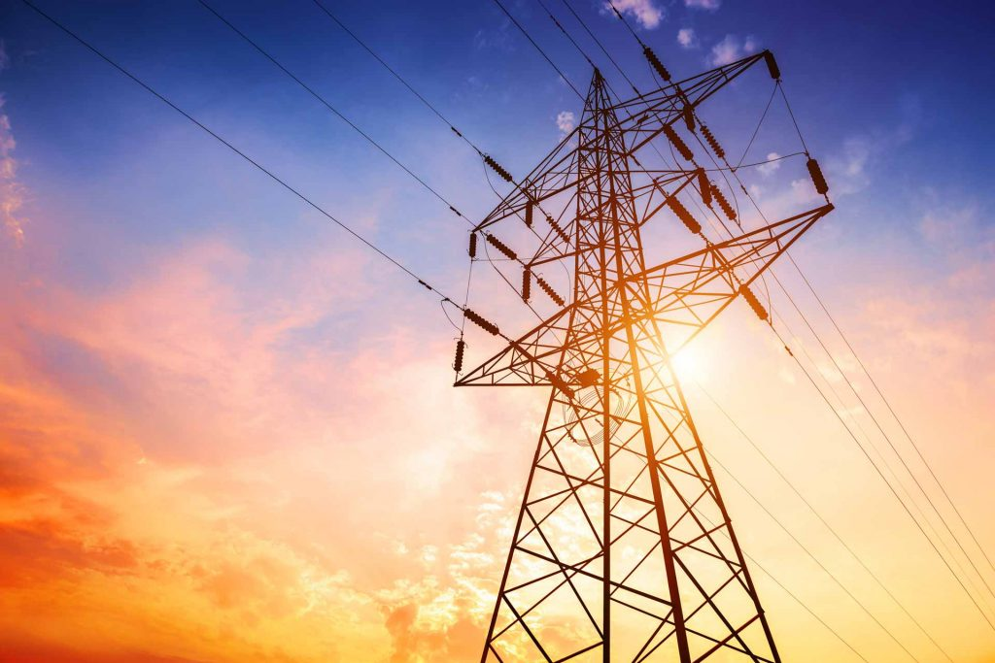

INTRODUCTION

DATASET LINK : https://www.kaggle.com/datasets/chakradharmattapalli/electricity-price-prediction

.

Electricity price prediction is the process of forecasting the future costs of electricity in a specific market or region. It plays a crucial role in energy management, allowing utility companies, consumers, and other stakeholders to make informed decisions regarding their energy consumption and investments. The goal of electricity price prediction is to provide accurate and timely estimates of electricity prices, typically on various time scales, such as hourly, daily, or even seasonal forecasts. Key factors that influence electricity prices include supply and demand dynamics, weather conditions, fuel prices, regulatory policies, infrastructure constraints, and market behaviour . To predict electricity prices, various data sources and predictive models are employed. These may include historical price data, weather forecasts, economic indicators, and machine learning algorithms. Effective electricity price prediction has numerous practical applications. It helps energy providers optimize their generation and distribution strategies, enabling cost-effective operations and improved grid reliability. Consumers can benefit by adjusting their consumption patterns to save money during periods of high prices. Additionally, investors and policymakers use these predictions to make informed decisions about energy infrastructure development and energy market regulation. Overall, accurate electricity price prediction is essential for the efficient functioning of electricity markets and the sustainable management of energy resources

NECESSARY STEPS TO FOLLOW:

Start by importing libraries

Pandas:

Pandas is essential for data manipulation and analysis, particularly for loading and handling datasets.

Program:

import pandas as pd

NumPy:

NumPy is used for numerical computations, and it complements Pandas for handling arrays and mathematical operations.

Program:

import NumPy as np

Scikit-Learn (sklearn):

Scikit-Learn provides tools for machine learning, including dataset splitting, preprocessing, and model evaluation. You'll import specific modules as needed for your analysis.

Program:

from sklearn. model selection import train_test_split

from sklearn. Preprocessing import StandardScaler # For data scaling (if needed)

LOAD THE DATASET:

To load a dataset for credit card fraud detection, We can use the Pandas library in Python. Here's how we can load a dataset from a CSV file, which is a common data format:

Program:

import pandas as pd

# Specify the file path to your dataset

File_path=(" C:/Users/mithu/Documents/natheesh/ Electricity.csv ")

# Use Pandas to read the CSV file into a DataFrame

df = pd.read_csv("C:/Users/mithu/Documents/natheesh/ Electricity.csv")

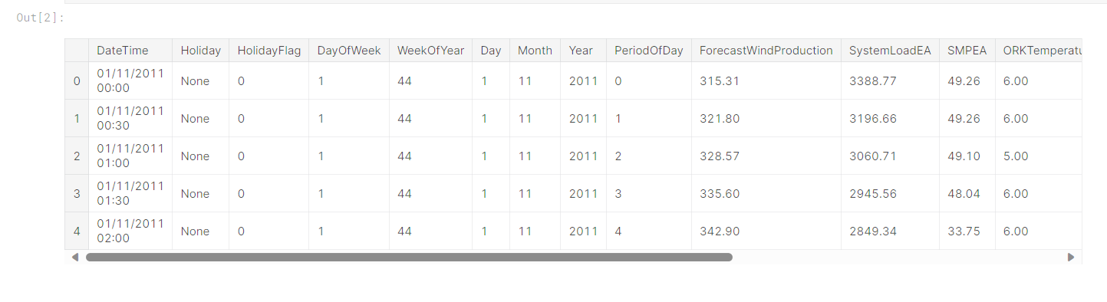

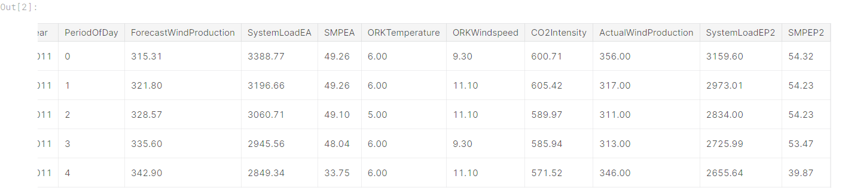

# Now, 'df' contains your dataset, and you can start working with it.

In the code above:

Import the Pandas library to work with data.

Replace 'your_dataset.csv' with the actual file path to our dataset. Make sure that the CSV file is in the same directory as our Python script, or provide the full path to the file if it's located elsewhere.

The pd.read_csv(file_path) function reads the CSV file and stores its contents in a Pandas DataFrame called df. This DataFrame is a two-dimensional table-like data structure that you can manipulate and analyze.

After loading the dataset into a Data Frame, we can perform various data analysis tasks, such as data exploration, preprocessing, and modelling, depending on your specific objectives in credit card fraud detection.

Data processing :

Data processing occurs when data is collected and translated into usable information. Usually performed by a data scientist or team of data scientists, it is important for data processing to be done correctly as not to negatively affect the end product, or data output.

Basic Summary Statistics:

Use Pandas to obtain summary statistics of the dataset, which can give a quick overview of the data, including counts, means, standard deviations, and percentiles.

Program:

print(df.describe())

Data Shape:

Use to see how many Rows and columns in our Dataset.

df**.**shape

(38014, 18)

Dependent and Independent Variables

So, y is referred to as dependent feature or variable of total_vaccinations and x is referred to as independent features or variables of location,date,vaccine,total_vaccinations. Any predictive mathematical model tends to divide the observations (data) into dependent/ independent features in order to determine the causal effect.

Program:

*#columns*

df.columns

Index(['DateTime', 'Holiday', 'HolidayFlag', 'DayOfWeek', 'WeekOfYear', 'Day',

'Month', 'Year', 'PeriodOfDay', 'ForecastWindProduction',

'SystemLoadEA', 'SMPEA', 'ORKTemperature', 'ORKWindspeed',

'CO2Intensity', 'ActualWindProduction', 'SystemLoadEP2', 'SMPEP2'],

dtype='object')

df.nunique()

DateTime 38014

Holiday 15

HolidayFlag 2

DayOfWeek 7

WeekOfYear 52

Day 31

Month 12

Year 3

PeriodOfDay 48

ForecastWindProduction 29312

SystemLoadEA 36166

SMPEA 8661

ORKTemperature 32

ORKWindspeed 53

CO2Intensity 25115

ActualWindProduction 2940

SystemLoadEP2 36171

SMPEP2 9277

dtype: int64

Sklearn.impute

The SimpleImputer class provides basic strategies for imputing missing values. Missing values can be imputed with a provided constant value, or using the statistics (mean, median or most frequent) of each column in which the missing values are located. This class also allows for different missing values encodings.

Program:

df.describe().T

output:

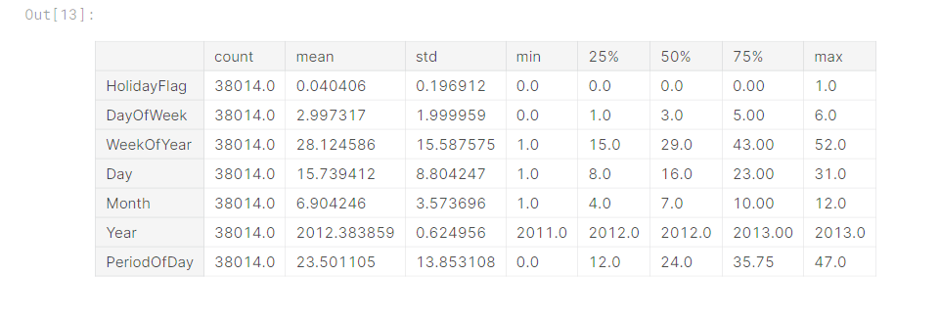

In

Label encoder

Label encoding is a technique used in machine learning and data analysis to convert categorical variables into numerical format. It is particularly useful when working with algorithms that require numerical input, as most machine learning models can only operate on numerical data.

Program:

To use machine learning models, analyse feature importance to understand which attributes play a significant role in covid-19 vaccine analysis

One-hot encoder

One-Hot Encoding is another popular technique for treating categorical variables. It simply creates additional features based on the number of unique values in the categorical feature. Every unique value in the category will be added as a feature. One-Hot Encoding is the process of creating dummy variables.

Program:

col=["Holiday","HolidayFlag","DayOfWeek","WeekOfYear","Day","Month",

"Year","PeriodOfDay","ORKTemperature"]

for i **in** col:

print(df[i].value_counts())

print("*"*30)

output:

None 36478

Christmas Eve 144

Christmas 144

St Stephen's Day 144

New Year's Eve 144

New Year's Day 96

St Patrick's Day 96

Good Friday 96

Holy Saturday 96

Easter 96

Easter Monday 96

May Day 96

June Bank Holiday 96

August Bank Holiday 96

October Bank Holiday 96

Name: Holiday, dtype: int64

******************************

0 36478

1 1536

Name: HolidayFlag, dtype: int64

******************************

1 5472

2 5424

3 5424

4 5424

5 5424

0 5424

6 5422

Name: DayOfWeek, dtype: int64

******************************

45 1008

46 1008

47 1008

48 1008

49 1008

50 1008

51 1008

52 1008

44 960

1 768

25 672

26 672

33 672

27 672

28 672

29 672

30 672

31 672

32 672

37 672

34 672

35 672

36 672

23 672

38 672

39 672

40 672

41 672

42 672

24 672

18 672

22 672

10 672

2 672

3 672

4 672

5 672

6 672

7 672

8 672

9 672

11 672

21 672

13 672

14 672

15 672

16 672

17 672

19 672

20 672

43 672

12 670

Name: WeekOfYear, dtype: int64

******************************

1 1248

15 1248

28 1248

27 1248

26 1248

24 1248

23 1248

22 1248

21 1248

20 1248

19 1248

18 1248

17 1248

2 1248

16 1248

14 1248

13 1248

12 1248

11 1248

10 1248

9 1248

8 1248

7 1248

6 1248

5 1248

4 1248

3 1248

25 1246

29 1200

30 1152

31 720

Name: Day, dtype: int64

******************************

12 4464

11 4320

1 2976

5 2976

7 2976

8 2976

10 2976

3 2974

4 2880

6 2880

9 2880

2 2736

Name: Month, dtype: int64

******************************

2012 17566

2013 17520

2011 2928

Name: Year, dtype: int64

******************************

0 792

1 792

26 792

27 792

28 792

29 792

30 792

31 792

32 792

33 792

34 792

35 792

36 792

37 792

38 792

39 792

40 792

41 792

42 792

43 792

44 792

45 792

46 792

25 792

24 792

23 792

22 792

4 792

5 792

6 792

7 792

8 792

9 792

10 792

11 792

12 792

13 792

14 792

15 792

16 792

17 792

18 792

19 792

20 792

21 792

47 792

3 791

2 791

Name: PeriodOfDay, dtype: int64

******************************

9.00 3525

10.00 3230

8.00 3225

11.00 3017

7.00 2894

12.00 2712

6.00 2617

5.00 2027

13.00 2009

15.00 1883

14.00 1855

4.00 1580

16.00 1451

3.00 1399

17.00 1001

2.00 953

18.00 592

1.00 531

19.00 330

? 295

0.00 213

20.00 195

21.00 135

-1.00 103

22.00 75

23.00 64

24.00 43

-2.00 30

-3.00 14

25.00 13

-4.00 2

-0.00 1

Name: ORKTemperature, dtype: int64

LabelEncoder Fit_transform

LabelEncoder , we can use the fit_transform function. This function fits the LabelEncoder object to the input data, and then transforms the data into encoded values. By default, fit_transform assigns a unique numerical value to each category in the input data.

Program:

df.describe([0.05,0.1,0.25,0.35,0.5,0.65,0.75,0.9,0.95,0.98]).T

output:

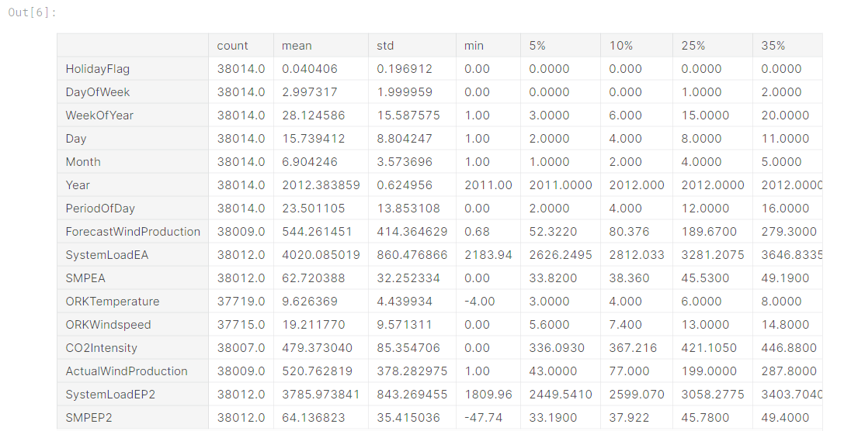

sklearn model_selection in train_test_split

train_test_split is a function in Sklearn model selection for splitting data arrays into two subsets: for training data and for testing data. With this function, you don't need to divide the dataset manually. By default, Sklearn train_test_split will make random partitions for the two subsets.

Program:

**from** sklearn.model_selection **import** train_test_split

x_train,x_test,y_train,y_test**=**train_test_split(x,y,test_size**=**0.2,train_size**=**0.4,random_state**=**0)

Input:

+ cat_list=[]

num_list=[]

for i **in** df.columns:

unique_val=len(df[i].unique())

if unique_val<40:

cat_list.append(i)

else:

num_list.append(i)

In [9]:

cat_list.append("WeekOfYear")

In [10]:

cat_list

output:

Out[10]:

['Holiday',

'HolidayFlag',

'DayOfWeek',

'Day',

'Month',

'Year',

'ORKTemperature',

'WeekOfYear']

Input:

x_test

output:

array([[23.709999, 23.790001, 23.15 , 23.219999],

[27.08 , 27.110001, 26.809999, 26.92 ],

[30.17 , 30.4 , 29.889999, 30.16 ],

...,

[17.40625 , 17.421875, 16.96875 , 17.125 ],

[37.349998, 37.599998, 37.299999, 37.470001],

[ 2.921875, 2.945313, 2.875 , 2.890625]])

Input:

df_remove_out["DateTime"] = pd.to_datetime(df_remove_out.DateTime)

In [50]:

df_remove_out['year'] = df_remove_out['DateTime'].dt.year

df_remove_out['month'] = df_remove_out['DateTime'].dt.month

df_remove_out["day"]=df_remove_out["DateTime"].dt.day

output

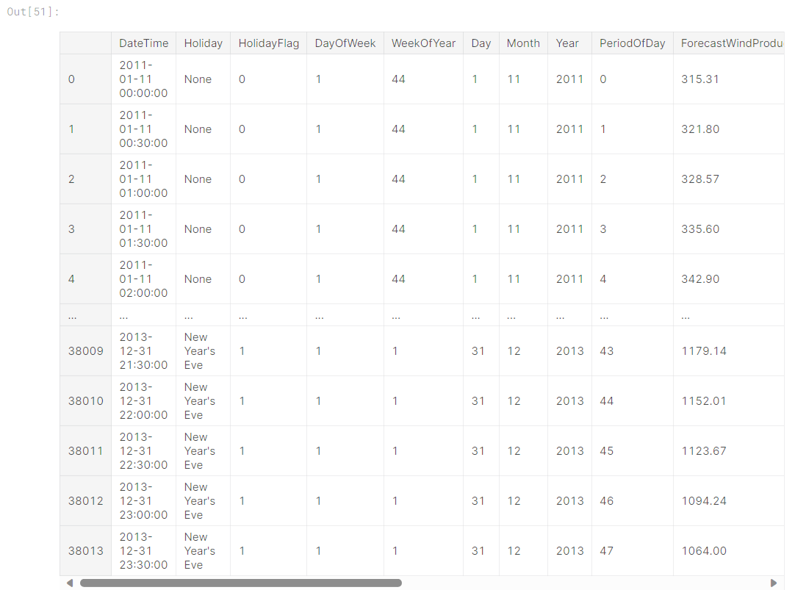

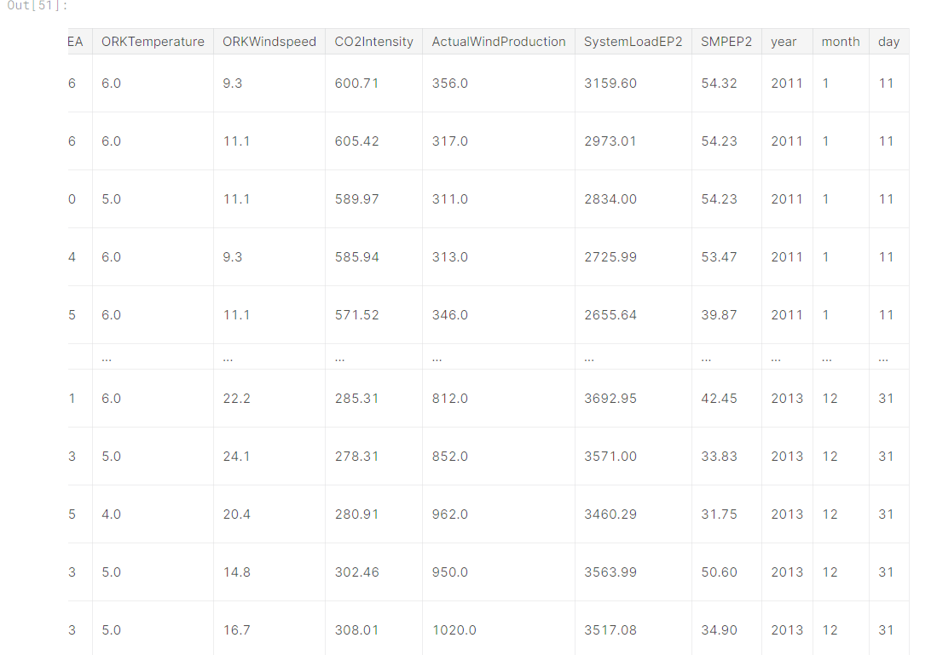

input:

sns.pairplot(df.loc[:,num_list]);

output:

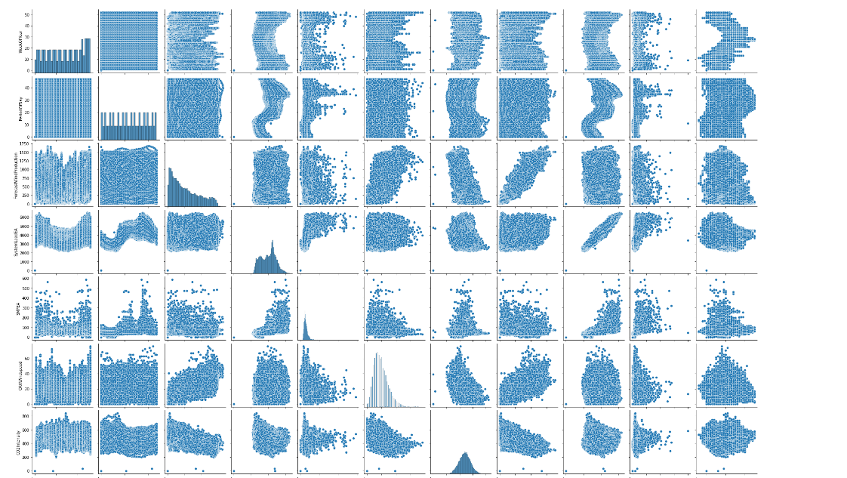

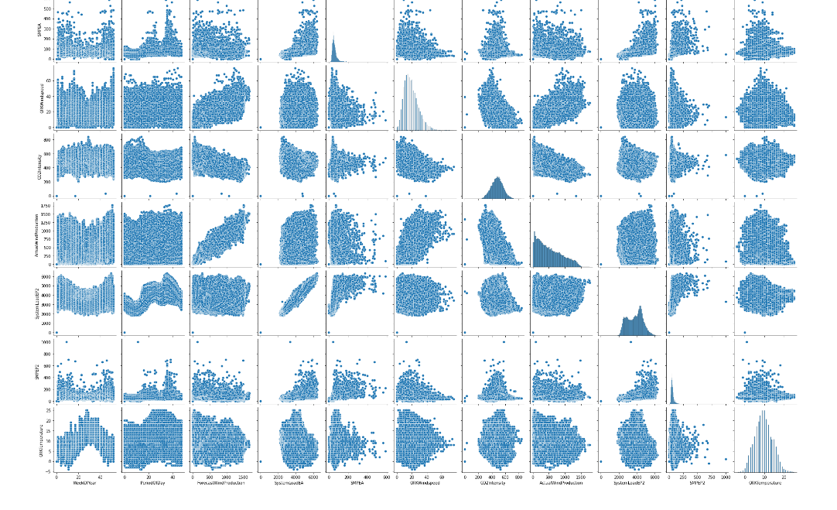

*# histogram*

df.hist(figsize=(9,9));

output:

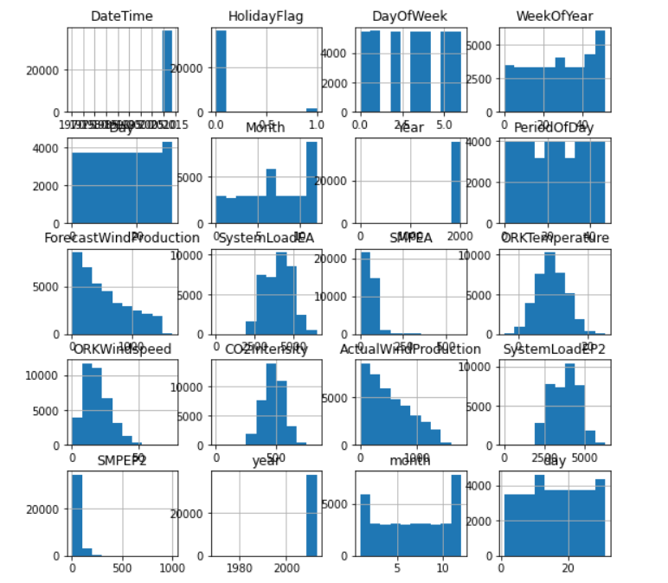

Input:

cat_list

output:

Out[55]:

['Holiday',

'HolidayFlag',

'DayOfWeek',

'Day',

'Month',

'Year',

'ORKTemperature',

'WeekOfYear']

Input:

In [56]:

num_list

output:

Out[56]:

['WeekOfYear',

'PeriodOfDay',

'ForecastWindProduction',

'SystemLoadEA',

'SMPEA',

'ORKWindspeed',

'CO2Intensity',

'ActualWindProduction',

'SystemLoadEP2',

'SMPEP2',

'ORKTemperature']

Program:

plt.figure(figsize=(15,15))

plt.subplot(3,2,1)

sns.barplot(x ='Year',y ='SystemLoadEA',data = df)

plt.subplot(3,2,2)

sns.barplot(x="DayOfWeek",y="SMPEP2",data=df)

plt.subplot(3,2,3)

sns.boxplot(x="Month",y="SMPEP2",data=df)

plt.subplot(3,2,4)

sns.boxplot(x="Day",y="ORKWindspeed",data=df)

plt.subplot(3,2,5)

sns.violinplot(x="Holiday",y="SystemLoadEA",data=df)

plt.subplot(3,2,6)

sns.barplot(x="Holiday",y="ORKWindspeed",data=df)

plt.show()

output:

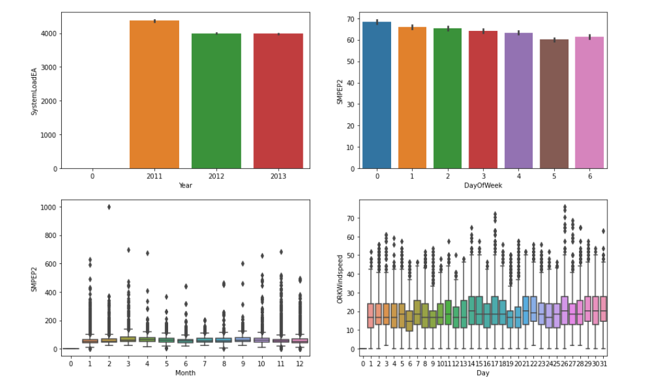

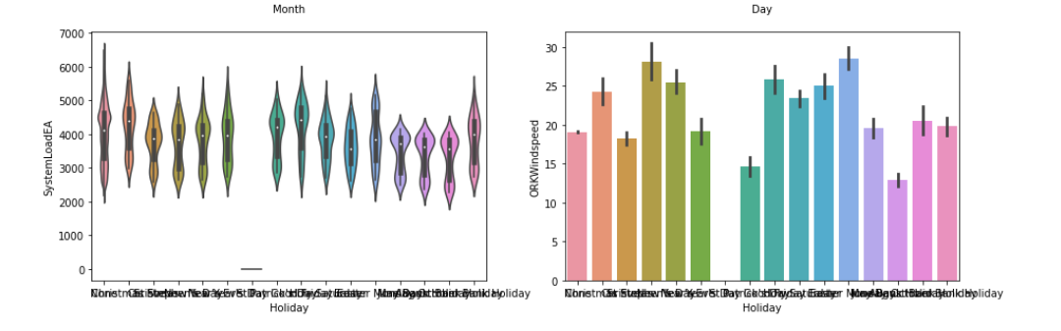

Program:

from xgboost import XGBRegressor

from catboost import CatBoostRegressor

from lightgbm import LGBMRegressor

In [74]:

ridge=Ridge().fit(X_train,y_train)

lasso=Lasso().fit(X_train,y_train)

enet=ElasticNet().fit(X_train,y_train)

knn=KNeighborsRegressor().fit(X_train,y_train)

ada=AdaBoostRegressor().fit(X_train,y_train)

In [76]:

svm=SVR().fit(X_train,y_train)

mlpc=MLPRegressor().fit(X_train,y_train)

dtc=DecisionTreeRegressor().fit(X_train,y_train)

rf=RandomForestRegressor().fit(X_train,y_train)

xgb=XGBRegressor().fit(X_train,y_train)

gbm=GradientBoostingRegressor().fit(X_train,y_train)

lgb=LGBMRegressor().fit(X_train,y_train)

catbost=CatBoostRegressor().fit(X_train,y_train)

Output:

Learning rate set to 0.06876

0: learn: 34.5202564 total: 64.1ms remaining: 1m 4s

1: learn: 33.6345770 total: 70ms remaining: 34.9s

2: learn: 32.8676895 total: 74.8ms remaining: 24.8s

3: learn: 32.1602282 total: 79.9ms remaining: 19.9s

4: learn: 31.4994441 total: 85.2ms remaining: 17s

5: learn: 30.9246676 total: 91ms remaining: 15.1s

6: learn: 30.4012671 total: 96.3ms remaining: 13.7s

7: learn: 29.9286504 total: 101ms remaining: 12.5s

8: learn: 29.5172364 total: 106ms remaining: 11.7s

9: learn: 29.1386738 total: 111ms remaining: 11s

10: learn: 28.7562568 total: 116ms remaining: 10.4s

11: learn: 28.4486528 total: 122ms remaining: 10s

12: learn: 28.1657127 total: 128ms remaining: 9.7s

13: learn: 27.8831288 total: 133ms remaining: 9.38s

14: learn: 27.6408000 total: 138ms remaining: 9.07s

15: learn: 27.4359313 total: 143ms remaining: 8.8s

16: learn: 27.2173157 total: 148ms remaining: 8.55s

17: learn: 27.0422970 total: 153ms remaining: 8.36s

18: learn: 26.8771233 total: 158ms remaining: 8.16s

19: learn: 26.6893652 total: 164ms remaining: 8.03s

20: learn: 26.5538529 total: 169ms remaining: 7.86s

21: learn: 26.4492316 total: 174ms remaining: 7.71s

22: learn: 26.3094102 total: 178ms remaining: 7.58s

23: learn: 26.1955562 total: 184ms remaining: 7.47s

24: learn: 26.0928013 total: 189ms remaining: 7.39s

25: learn: 25.9962431 total: 195ms remaining: 7.3s

26: learn: 25.9124311 total: 200ms remaining: 7.19s

27: learn: 25.8302408 total: 204ms remaining: 7.09s

28: learn: 25.7387686 total: 209ms remaining: 7s

29: learn: 25.6728034 total: 214ms remaining: 6.92s

30: learn: 25.5926581 total: 219ms remaining: 6.84s

31: learn: 25.4940606 total: 224ms remaining: 6.77s

32: learn: 25.4182581 total: 229ms remaining: 6.7s

33: learn: 25.3652752 total: 233ms remaining: 6.63s

34: learn: 25.3223579 total: 238ms remaining: 6.56s

35: learn: 25.2489125 total: 243ms remaining: 6.5s

36: learn: 25.2076996 total: 247ms remaining: 6.43s

37: learn: 25.1667858 total: 252ms remaining: 6.38s

38: learn: 25.1180288 total: 257ms remaining: 6.34s

39: learn: 25.0752794 total: 262ms remaining: 6.3s

40: learn: 25.0339522 total: 267ms remaining: 6.25s

41: learn: 24.9977064 total: 272ms remaining: 6.2s

42: learn: 24.9697517 total: 276ms remaining: 6.15s

43: learn: 24.9190191 total: 281ms remaining: 6.11s

44: learn: 24.8957832 total: 285ms remaining: 6.06s

45: learn: 24.8597053 total: 290ms remaining: 6.01s

46: learn: 24.8392094 total: 294ms remaining: 5.97s

47: learn: 24.8102239 total: 299ms remaining: 5.92s

48: learn: 24.7789045 total: 303ms remaining: 5.89s

49: learn: 24.7500880 total: 308ms remaining: 5.85s

50: learn: 24.7178926 total: 313ms remaining: 5.82s

51: learn: 24.6968006 total: 317ms remaining: 5.78s

52: learn: 24.6800087 total: 321ms remaining: 5.74s

53: learn: 24.6507233 total: 326ms remaining: 5.71s

54: learn: 24.6186034 total: 331ms remaining: 5.68s

55: learn: 24.5907057 total: 335ms remaining: 5.65s

56: learn: 24.5572812 total: 340ms remaining: 5.63s

57: learn: 24.5264215 total: 345ms remaining: 5.6s

58: learn: 24.4987088 total: 350ms remaining: 5.58s

59: learn: 24.4794572 total: 355ms remaining: 5.56s

60: learn: 24.4427210 total: 359ms remaining: 5.53s

61: learn: 24.4156283 total: 364ms remaining: 5.51s

62: learn: 24.3917659 total: 369ms remaining: 5.49s

63: learn: 24.3642679 total: 374ms remaining: 5.47s

64: learn: 24.3450265 total: 379ms remaining: 5.45s

65: learn: 24.3204788 total: 383ms remaining: 5.42s

66: learn: 24.2830890 total: 389ms remaining: 5.41s

67: learn: 24.2650713 total: 393ms remaining: 5.39s

68: learn: 24.2399899 total: 397ms remaining: 5.36s

69: learn: 24.2164965 total: 402ms remaining: 5.34s

70: learn: 24.1964369 total: 407ms remaining: 5.32s

71: learn: 24.1807660 total: 412ms remaining: 5.31s

72: learn: 24.1689245 total: 417ms remaining: 5.29s

73: learn: 24.1436655 total: 421ms remaining: 5.27s

74: learn: 24.1253300 total: 426ms remaining: 5.25s

75: learn: 24.0935058 total: 430ms remaining: 5.23s

76: learn: 24.0763530 total: 435ms remaining: 5.21s

77: learn: 24.0532679 total: 439ms remaining: 5.19s

78: learn: 24.0366265 total: 443ms remaining: 5.17s

79: learn: 24.0167814 total: 448ms remaining: 5.15s

80: learn: 23.9978824 total: 453ms remaining: 5.14s

81: learn: 23.9867891 total: 457ms remaining: 5.12s

82: learn: 23.9763622 total: 462ms remaining: 5.1s

83: learn: 23.9460132 total: 467ms remaining: 5.09s

84: learn: 23.9186528 total: 471ms remaining: 5.07s

85: learn: 23.9048177 total: 476ms remaining: 5.06s

86: learn: 23.8918401 total: 481ms remaining: 5.05s

87: learn: 23.8653562 total: 486ms remaining: 5.04s

88: learn: 23.8508496 total: 491ms remaining: 5.02s

89: learn: 23.8371390 total: 495ms remaining: 5.01s

90: learn: 23.8302205 total: 500ms remaining: 4.99s

91: learn: 23.8033151 total: 504ms remaining: 4.98s

92: learn: 23.7824900 total: 509ms remaining: 4.96s

93: learn: 23.7735478 total: 514ms remaining: 4.96s

94: learn: 23.7586709 total: 519ms remaining: 4.94s

95: learn: 23.7389694 total: 523ms remaining: 4.93s

96: learn: 23.7269390 total: 528ms remaining: 4.91s

97: learn: 23.7126293 total: 532ms remaining: 4.9s

98: learn: 23.6890770 total: 537ms remaining: 4.88s

99: learn: 23.6685269 total: 541ms remaining: 4.87s

100: learn: 23.6485375 total: 546ms remaining: 4.86s

101: learn: 23.6257557 total: 551ms remaining: 4.85s

102: learn: 23.6065188 total: 556ms remaining: 4.84s

103: learn: 23.5901493 total: 561ms remaining: 4.83s

104: learn: 23.5784682 total: 565ms remaining: 4.82s

105: learn: 23.5614537 total: 570ms remaining: 4.81s

106: learn: 23.5429277 total: 574ms remaining: 4.79s

107: learn: 23.5283062 total: 579ms remaining: 4.78s

108: learn: 23.5054101 total: 584ms remaining: 4.77s

109: learn: 23.4962552 total: 590ms remaining: 4.78s

110: learn: 23.4881442 total: 595ms remaining: 4.77s

111: learn: 23.4706061 total: 600ms remaining: 4.76s

112: learn: 23.4534164 total: 605ms remaining: 4.75s

113: learn: 23.4365195 total: 609ms remaining: 4.73s

114: learn: 23.4195741 total: 614ms remaining: 4.72s

115: learn: 23.4091888 total: 618ms remaining: 4.71s

116: learn: 23.3965487 total: 623ms remaining: 4.7s

117: learn: 23.3908567 total: 627ms remaining: 4.68s

118: learn: 23.3690200 total: 631ms remaining: 4.67s

119: learn: 23.3549188 total: 636ms remaining: 4.67s

120: learn: 23.3456578 total: 641ms remaining: 4.65s

121: learn: 23.3360274 total: 646ms remaining: 4.65s

122: learn: 23.3231595 total: 651ms remaining: 4.64s

123: learn: 23.3023755 total: 656ms remaining: 4.63s

124: learn: 23.2885021 total: 660ms remaining: 4.62s

125: learn: 23.2651892 total: 664ms remaining: 4.61s

126: learn: 23.2498197 total: 669ms remaining: 4.6s

127: learn: 23.2388304 total: 674ms remaining: 4.59s

128: learn: 23.2210668 total: 679ms remaining: 4.58s

129: learn: 23.2035920 total: 683ms remaining: 4.57s

130: learn: 23.1842992 total: 687ms remaining: 4.56s

131: learn: 23.1610585 total: 692ms remaining: 4.55s

132: learn: 23.1544365 total: 696ms remaining: 4.54s

133: learn: 23.1421105 total: 701ms remaining: 4.53s

134: learn: 23.1286098 total: 705ms remaining: 4.52s

135: learn: 23.1054294 total: 710ms remaining: 4.51s

136: learn: 23.0922696 total: 715ms remaining: 4.5s

137: learn: 23.0796668 total: 719ms remaining: 4.49s

138: learn: 23.0731800 total: 724ms remaining: 4.48s

139: learn: 23.0427388 total: 728ms remaining: 4.47s

140: learn: 23.0308310 total: 733ms remaining: 4.46s

141: learn: 23.0163469 total: 738ms remaining: 4.46s

142: learn: 22.9997343 total: 742ms remaining: 4.45s

143: learn: 22.9723466 total: 747ms remaining: 4.44s

144: learn: 22.9513865 total: 752ms remaining: 4.43s

145: learn: 22.9292088 total: 756ms remaining: 4.42s

146: learn: 22.9153292 total: 761ms remaining: 4.42s

147: learn: 22.8982178 total: 765ms remaining: 4.41s

148: learn: 22.8817084 total: 770ms remaining: 4.4s

149: learn: 22.8649860 total: 775ms remaining: 4.39s

150: learn: 22.8445042 total: 781ms remaining: 4.39s

151: learn: 22.8351444 total: 791ms remaining: 4.41s

152: learn: 22.8160607 total: 798ms remaining: 4.42s

153: learn: 22.8108585 total: 803ms remaining: 4.41s

154: learn: 22.8005951 total: 809ms remaining: 4.41s

155: learn: 22.7780667 total: 814ms remaining: 4.4s

156: learn: 22.7604956 total: 818ms remaining: 4.39s

157: learn: 22.7481029 total: 823ms remaining: 4.38s

158: learn: 22.7356844 total: 827ms remaining: 4.37s

159: learn: 22.7239980 total: 832ms remaining: 4.37s

160: learn: 22.7139082 total: 837ms remaining: 4.36s

161: learn: 22.6963356 total: 841ms remaining: 4.35s

162: learn: 22.6779827 total: 847ms remaining: 4.35s

163: learn: 22.6630876 total: 851ms remaining: 4.34s

164: learn: 22.6469348 total: 856ms remaining: 4.33s

165: learn: 22.6284631 total: 861ms remaining: 4.32s

166: learn: 22.6090313 total: 865ms remaining: 4.32s

167: learn: 22.5975224 total: 870ms remaining: 4.31s

168: learn: 22.5861446 total: 874ms remaining: 4.3s

169: learn: 22.5605659 total: 879ms remaining: 4.29s

170: learn: 22.5434031 total: 884ms remaining: 4.29s

171: learn: 22.5342445 total: 888ms remaining: 4.28s

172: learn: 22.5198132 total: 893ms remaining: 4.27s

173: learn: 22.5011294 total: 897ms remaining: 4.26s

174: learn: 22.4779683 total: 902ms remaining: 4.25s

175: learn: 22.4707622 total: 906ms remaining: 4.24s

176: learn: 22.4570845 total: 911ms remaining: 4.24s

177: learn: 22.4440897 total: 916ms remaining: 4.23s

178: learn: 22.4284477 total: 921ms remaining: 4.22s

179: learn: 22.3999147 total: 925ms remaining: 4.21s

180: learn: 22.3855202 total: 930ms remaining: 4.21s

181: learn: 22.3699849 total: 935ms remaining: 4.2s

182: learn: 22.3554998 total: 940ms remaining: 4.2s

183: learn: 22.3417492 total: 945ms remaining: 4.19s

184: learn: 22.3294693 total: 950ms remaining: 4.18s

185: learn: 22.3101989 total: 955ms remaining: 4.18s

186: learn: 22.3013808 total: 959ms remaining: 4.17s

187: learn: 22.2897784 total: 963ms remaining: 4.16s

188: learn: 22.2724282 total: 968ms remaining: 4.15s

189: learn: 22.2637859 total: 973ms remaining: 4.15s

190: learn: 22.2463705 total: 977ms remaining: 4.14s

191: learn: 22.2310312 total: 983ms remaining: 4.13s

192: learn: 22.2180158 total: 988ms remaining: 4.13s

193: learn: 22.2058401 total: 994ms remaining: 4.13s

194: learn: 22.1929670 total: 999ms remaining: 4.13s

195: learn: 22.1774777 total: 1s remaining: 4.12s

196: learn: 22.1538412 total: 1.01s remaining: 4.12s

197: learn: 22.1445249 total: 1.01s remaining: 4.11s

198: learn: 22.1220470 total: 1.02s remaining: 4.1s

199: learn: 22.1012257 total: 1.02s remaining: 4.09s

200: learn: 22.0857517 total: 1.03s remaining: 4.09s

201: learn: 22.0674978 total: 1.03s remaining: 4.08s

202: learn: 22.0590450 total: 1.04s remaining: 4.07s

203: learn: 22.0456647 total: 1.04s remaining: 4.07s

204: learn: 22.0339836 total: 1.05s remaining: 4.06s

205: learn: 22.0200405 total: 1.05s remaining: 4.06s

206: learn: 22.0117626 total: 1.06s remaining: 4.05s

207: learn: 21.9903273 total: 1.06s remaining: 4.04s

208: learn: 21.9848345 total: 1.07s remaining: 4.04s

209: learn: 21.9748915 total: 1.07s remaining: 4.03s

210: learn: 21.9696034 total: 1.07s remaining: 4.02s

211: learn: 21.9625675 total: 1.08s remaining: 4.01s

212: learn: 21.9536509 total: 1.08s remaining: 4s

213: learn: 21.9460636 total: 1.09s remaining: 4s

214: learn: 21.9324849 total: 1.09s remaining: 3.99s

215: learn: 21.9116324 total: 1.1s remaining: 3.98s

216: learn: 21.9000166 total: 1.1s remaining: 3.98s

217: learn: 21.8885071 total: 1.11s remaining: 3.97s

218: learn: 21.8658144 total: 1.11s remaining: 3.96s

219: learn: 21.8566155 total: 1.12s remaining: 3.96s

220: learn: 21.8478881 total: 1.12s remaining: 3.95s

221: learn: 21.8328650 total: 1.13s remaining: 3.95s

222: learn: 21.8245068 total: 1.13s remaining: 3.94s

223: learn: 21.8141118 total: 1.14s remaining: 3.93s

224: learn: 21.8034802 total: 1.14s remaining: 3.93s

225: learn: 21.7919097 total: 1.14s remaining: 3.92s

226: learn: 21.7711303 total: 1.15s remaining: 3.91s

227: learn: 21.7652844 total: 1.15s remaining: 3.91s

228: learn: 21.7530581 total: 1.16s remaining: 3.9s

229: learn: 21.7484892 total: 1.16s remaining: 3.9s

230: learn: 21.7321872 total: 1.17s remaining: 3.89s

231: learn: 21.7205130 total: 1.17s remaining: 3.88s

232: learn: 21.7113400 total: 1.18s remaining: 3.88s

233: learn: 21.7018807 total: 1.18s remaining: 3.87s

234: learn: 21.6854236 total: 1.19s remaining: 3.87s

235: learn: 21.6664150 total: 1.19s remaining: 3.86s

236: learn: 21.6495599 total: 1.2s remaining: 3.86s

237: learn: 21.6403905 total: 1.2s remaining: 3.85s

238: learn: 21.6360714 total: 1.21s remaining: 3.84s

239: learn: 21.6237335 total: 1.21s remaining: 3.84s

240: learn: 21.6129724 total: 1.22s remaining: 3.83s

241: learn: 21.6007000 total: 1.22s remaining: 3.82s

242: learn: 21.5915420 total: 1.23s remaining: 3.82s

243: learn: 21.5787274 total: 1.23s remaining: 3.81s

244: learn: 21.5719220 total: 1.23s remaining: 3.8s

245: learn: 21.5611508 total: 1.24s remaining: 3.8s

246: learn: 21.5471182 total: 1.24s remaining: 3.79s

247: learn: 21.5304724 total: 1.25s remaining: 3.79s

248: learn: 21.5220211 total: 1.25s remaining: 3.78s

249: learn: 21.5027181 total: 1.26s remaining: 3.77s

250: learn: 21.4910844 total: 1.26s remaining: 3.77s

251: learn: 21.4840957 total: 1.27s remaining: 3.76s

252: learn: 21.4713155 total: 1.27s remaining: 3.75s

253: learn: 21.4632055 total: 1.28s remaining: 3.75s

254: learn: 21.4462107 total: 1.28s remaining: 3.74s

255: learn: 21.4382139 total: 1.28s remaining: 3.73s

256: learn: 21.4222464 total: 1.29s remaining: 3.73s

257: learn: 21.4116674 total: 1.29s remaining: 3.73s

258: learn: 21.4026922 total: 1.3s remaining: 3.72s

259: learn: 21.3927899 total: 1.3s remaining: 3.71s

260: learn: 21.3848766 total: 1.31s remaining: 3.71s

261: learn: 21.3775206 total: 1.31s remaining: 3.7s

262: learn: 21.3677941 total: 1.32s remaining: 3.69s

263: learn: 21.3560543 total: 1.32s remaining: 3.69s

264: learn: 21.3485618 total: 1.33s remaining: 3.69s

265: learn: 21.3344959 total: 1.33s remaining: 3.68s

266: learn: 21.3251689 total: 1.34s remaining: 3.67s

267: learn: 21.3097922 total: 1.34s remaining: 3.67s

268: learn: 21.3031173 total: 1.35s remaining: 3.66s

269: learn: 21.2836365 total: 1.35s remaining: 3.66s

270: learn: 21.2721657 total: 1.36s remaining: 3.65s

271: learn: 21.2575044 total: 1.36s remaining: 3.64s

272: learn: 21.2447532 total: 1.37s remaining: 3.64s

273: learn: 21.2331770 total: 1.37s remaining: 3.63s

274: learn: 21.2207141 total: 1.38s remaining: 3.63s

275: learn: 21.2145930 total: 1.38s remaining: 3.62s

276: learn: 21.1975455 total: 1.39s remaining: 3.62s

277: learn: 21.1858717 total: 1.39s remaining: 3.61s

278: learn: 21.1747036 total: 1.4s remaining: 3.61s

279: learn: 21.1630873 total: 1.4s remaining: 3.6s

280: learn: 21.1509009 total: 1.41s remaining: 3.6s

281: learn: 21.1381192 total: 1.41s remaining: 3.59s

282: learn: 21.1323824 total: 1.42s remaining: 3.59s

283: learn: 21.1219955 total: 1.42s remaining: 3.58s

284: learn: 21.1165821 total: 1.42s remaining: 3.57s

285: learn: 21.1097781 total: 1.43s remaining: 3.57s

286: learn: 21.0940658 total: 1.43s remaining: 3.56s

287: learn: 21.0840193 total: 1.44s remaining: 3.56s

288: learn: 21.0602990 total: 1.44s remaining: 3.55s

289: learn: 21.0527837 total: 1.45s remaining: 3.54s

290: learn: 21.0435207 total: 1.45s remaining: 3.54s

291: learn: 21.0270484 total: 1.46s remaining: 3.53s

292: learn: 21.0060156 total: 1.46s remaining: 3.53s

293: learn: 20.9961423 total: 1.47s remaining: 3.52s

294: learn: 20.9846427 total: 1.47s remaining: 3.52s

295: learn: 20.9746407 total: 1.48s remaining: 3.51s

296: learn: 20.9644827 total: 1.48s remaining: 3.5s

297: learn: 20.9542928 total: 1.49s remaining: 3.5s

298: learn: 20.9476265 total: 1.49s remaining: 3.49s

299: learn: 20.9377276 total: 1.5s remaining: 3.49s

300: learn: 20.9315647 total: 1.5s remaining: 3.48s

301: learn: 20.9248077 total: 1.5s remaining: 3.48s

302: learn: 20.9164150 total: 1.51s remaining: 3.47s

303: learn: 20.9054389 total: 1.51s remaining: 3.47s

304: learn: 20.8922442 total: 1.52s remaining: 3.46s

305: learn: 20.8834223 total: 1.52s remaining: 3.45s

306: learn: 20.8776484 total: 1.53s remaining: 3.45s

307: learn: 20.8625846 total: 1.53s remaining: 3.44s

308: learn: 20.8538406 total: 1.54s remaining: 3.44s

309: learn: 20.8458101 total: 1.54s remaining: 3.43s

310: learn: 20.8320806 total: 1.55s remaining: 3.43s

311: learn: 20.8227726 total: 1.55s remaining: 3.42s

312: learn: 20.8133405 total: 1.56s remaining: 3.42s

313: learn: 20.8027681 total: 1.56s remaining: 3.41s

314: learn: 20.7961257 total: 1.57s remaining: 3.41s

315: learn: 20.7857454 total: 1.57s remaining: 3.4s

316: learn: 20.7761985 total: 1.58s remaining: 3.4s

317: learn: 20.7528806 total: 1.58s remaining: 3.39s

318: learn: 20.7465538 total: 1.59s remaining: 3.39s

319: learn: 20.7419486 total: 1.59s remaining: 3.38s

320: learn: 20.7300861 total: 1.6s remaining: 3.38s

321: learn: 20.7218380 total: 1.6s remaining: 3.37s

322: learn: 20.7128742 total: 1.6s remaining: 3.37s

323: learn: 20.6906583 total: 1.61s remaining: 3.36s

324: learn: 20.6834622 total: 1.61s remaining: 3.35s

325: learn: 20.6738032 total: 1.62s remaining: 3.35s

326: learn: 20.6651473 total: 1.62s remaining: 3.34s

327: learn: 20.6579486 total: 1.63s remaining: 3.34s

328: learn: 20.6457687 total: 1.63s remaining: 3.33s

329: learn: 20.6350139 total: 1.64s remaining: 3.33s

330: learn: 20.6263192 total: 1.64s remaining: 3.32s

331: learn: 20.6161134 total: 1.65s remaining: 3.32s

332: learn: 20.6067597 total: 1.65s remaining: 3.31s

333: learn: 20.5999420 total: 1.66s remaining: 3.31s

334: learn: 20.5873128 total: 1.66s remaining: 3.3s

335: learn: 20.5789074 total: 1.67s remaining: 3.29s

336: learn: 20.5696352 total: 1.67s remaining: 3.29s

337: learn: 20.5480881 total: 1.68s remaining: 3.29s

338: learn: 20.5437928 total: 1.68s remaining: 3.28s

339: learn: 20.5358888 total: 1.69s remaining: 3.27s

340: learn: 20.5288754 total: 1.69s remaining: 3.27s

341: learn: 20.5227467 total: 1.7s remaining: 3.26s

342: learn: 20.5171796 total: 1.7s remaining: 3.26s

343: learn: 20.5102402 total: 1.71s remaining: 3.25s

344: learn: 20.5045605 total: 1.71s remaining: 3.25s

345: learn: 20.4893346 total: 1.71s remaining: 3.24s

346: learn: 20.4806961 total: 1.72s remaining: 3.23s

347: learn: 20.4657527 total: 1.72s remaining: 3.23s

348: learn: 20.4605171 total: 1.73s remaining: 3.22s

349: learn: 20.4397125 total: 1.73s remaining: 3.22s

350: learn: 20.4249603 total: 1.74s remaining: 3.21s

351: learn: 20.4133891 total: 1.74s remaining: 3.21s

352: learn: 20.4051192 total: 1.75s remaining: 3.2s

353: learn: 20.3944160 total: 1.75s remaining: 3.2s

354: learn: 20.3745009 total: 1.76s remaining: 3.19s

355: learn: 20.3577903 total: 1.76s remaining: 3.19s

356: learn: 20.3505986 total: 1.76s remaining: 3.18s

357: learn: 20.3438530 total: 1.77s remaining: 3.17s

358: learn: 20.3385139 total: 1.77s remaining: 3.17s

359: learn: 20.3277795 total: 1.78s remaining: 3.16s

360: learn: 20.3196343 total: 1.78s remaining: 3.16s

361: learn: 20.3135182 total: 1.79s remaining: 3.15s

362: learn: 20.3029555 total: 1.79s remaining: 3.15s

363: learn: 20.2976558 total: 1.8s remaining: 3.15s

364: learn: 20.2932714 total: 1.8s remaining: 3.14s

365: learn: 20.2800459 total: 1.81s remaining: 3.14s

366: learn: 20.2664622 total: 1.81s remaining: 3.13s

367: learn: 20.2574043 total: 1.82s remaining: 3.13s

368: learn: 20.2456806 total: 1.82s remaining: 3.12s

369: learn: 20.2345700 total: 1.83s remaining: 3.12s

370: learn: 20.2306559 total: 1.83s remaining: 3.11s

371: learn: 20.2243896 total: 1.84s remaining: 3.1s

372: learn: 20.2130629 total: 1.84s remaining: 3.1s

373: learn: 20.2031139 total: 1.85s remaining: 3.09s

374: learn: 20.1984707 total: 1.85s remaining: 3.09s

375: learn: 20.1936481 total: 1.86s remaining: 3.08s

376: learn: 20.1843093 total: 1.86s remaining: 3.08s

377: learn: 20.1762840 total: 1.87s remaining: 3.07s

378: learn: 20.1710648 total: 1.87s remaining: 3.07s

379: learn: 20.1581832 total: 1.88s remaining: 3.06s

380: learn: 20.1506039 total: 1.88s remaining: 3.06s

381: learn: 20.1456723 total: 1.89s remaining: 3.05s

382: learn: 20.1381219 total: 1.89s remaining: 3.04s

383: learn: 20.1220837 total: 1.9s remaining: 3.04s

384: learn: 20.1089308 total: 1.9s remaining: 3.04s

385: learn: 20.0956516 total: 1.9s remaining: 3.03s

386: learn: 20.0913941 total: 1.91s remaining: 3.02s

387: learn: 20.0852063 total: 1.91s remaining: 3.02s

388: learn: 20.0759727 total: 1.92s remaining: 3.01s

389: learn: 20.0659595 total: 1.92s remaining: 3.01s

390: learn: 20.0564418 total: 1.93s remaining: 3s

391: learn: 20.0528602 total: 1.93s remaining: 3s

392: learn: 20.0426961 total: 1.94s remaining: 2.99s

393: learn: 20.0347749 total: 1.94s remaining: 2.99s

394: learn: 20.0240410 total: 1.95s remaining: 2.98s

395: learn: 20.0134671 total: 1.95s remaining: 2.98s

396: learn: 20.0043617 total: 1.96s remaining: 2.97s

397: learn: 19.9976176 total: 1.96s remaining: 2.97s

398: learn: 19.9898143 total: 1.97s remaining: 2.96s

399: learn: 19.9856700 total: 1.97s remaining: 2.96s

400: learn: 19.9793788 total: 1.98s remaining: 2.95s

401: learn: 19.9752518 total: 1.98s remaining: 2.94s

402: learn: 19.9662219 total: 1.98s remaining: 2.94s

403: learn: 19.9599596 total: 1.99s remaining: 2.94s

404: learn: 19.9487409 total: 1.99s remaining: 2.93s

405: learn: 19.9430188 total: 2s remaining: 2.92s

406: learn: 19.9380537 total: 2s remaining: 2.92s

407: learn: 19.9294568 total: 2.01s remaining: 2.92s

408: learn: 19.9190988 total: 2.01s remaining: 2.91s

409: learn: 19.9149594 total: 2.02s remaining: 2.9s

410: learn: 19.9078169 total: 2.02s remaining: 2.9s

411: learn: 19.9048141 total: 2.03s remaining: 2.89s

412: learn: 19.8946814 total: 2.03s remaining: 2.89s

413: learn: 19.8818974 total: 2.04s remaining: 2.88s

414: learn: 19.8619697 total: 2.04s remaining: 2.88s

415: learn: 19.8545794 total: 2.04s remaining: 2.87s

416: learn: 19.8430588 total: 2.05s remaining: 2.87s

417: learn: 19.8362499 total: 2.06s remaining: 2.86s

418: learn: 19.8301207 total: 2.06s remaining: 2.86s

419: learn: 19.8209515 total: 2.06s remaining: 2.85s

420: learn: 19.8131676 total: 2.07s remaining: 2.85s

421: learn: 19.8098102 total: 2.07s remaining: 2.84s

422: learn: 19.8040699 total: 2.08s remaining: 2.84s

423: learn: 19.7974575 total: 2.08s remaining: 2.83s

424: learn: 19.7885924 total: 2.09s remaining: 2.83s

425: learn: 19.7824471 total: 2.1s remaining: 2.82s

426: learn: 19.7735555 total: 2.1s remaining: 2.82s

427: learn: 19.7593927 total: 2.1s remaining: 2.81s

428: learn: 19.7526905 total: 2.11s remaining: 2.81s

429: learn: 19.7451743 total: 2.11s remaining: 2.8s

430: learn: 19.7398743 total: 2.12s remaining: 2.8s

431: learn: 19.7280254 total: 2.12s remaining: 2.79s

432: learn: 19.7155055 total: 2.13s remaining: 2.79s

433: learn: 19.7061785 total: 2.13s remaining: 2.78s

434: learn: 19.7002179 total: 2.14s remaining: 2.78s

435: learn: 19.6939389 total: 2.14s remaining: 2.77s

436: learn: 19.6886546 total: 2.15s remaining: 2.77s

437: learn: 19.6803601 total: 2.15s remaining: 2.76s

438: learn: 19.6755435 total: 2.16s remaining: 2.76s

439: learn: 19.6640605 total: 2.16s remaining: 2.75s

440: learn: 19.6560123 total: 2.17s remaining: 2.75s

441: learn: 19.6494601 total: 2.17s remaining: 2.74s

442: learn: 19.6391702 total: 2.18s remaining: 2.74s

443: learn: 19.6326979 total: 2.18s remaining: 2.73s

444: learn: 19.6263540 total: 2.19s remaining: 2.73s

445: learn: 19.6121938 total: 2.19s remaining: 2.72s

446: learn: 19.6077229 total: 2.2s remaining: 2.72s

447: learn: 19.6019808 total: 2.2s remaining: 2.71s

448: learn: 19.5940007 total: 2.21s remaining: 2.71s

449: learn: 19.5851500 total: 2.21s remaining: 2.7s

450: learn: 19.5753237 total: 2.21s remaining: 2.7s

451: learn: 19.5709741 total: 2.22s remaining: 2.69s

452: learn: 19.5649010 total: 2.22s remaining: 2.69s

453: learn: 19.5589679 total: 2.23s remaining: 2.68s

454: learn: 19.5526059 total: 2.23s remaining: 2.68s

455: learn: 19.5434327 total: 2.24s remaining: 2.67s

456: learn: 19.5346505 total: 2.24s remaining: 2.67s

457: learn: 19.5249278 total: 2.25s remaining: 2.66s

458: learn: 19.5190688 total: 2.25s remaining: 2.66s

459: learn: 19.5117442 total: 2.26s remaining: 2.65s

460: learn: 19.5051594 total: 2.26s remaining: 2.65s

461: learn: 19.5013621 total: 2.27s remaining: 2.64s

462: learn: 19.4959847 total: 2.27s remaining: 2.64s

463: learn: 19.4754181 total: 2.28s remaining: 2.63s

464: learn: 19.4681261 total: 2.28s remaining: 2.63s

465: learn: 19.4554274 total: 2.29s remaining: 2.62s

466: learn: 19.4514431 total: 2.29s remaining: 2.62s

467: learn: 19.4419712 total: 2.29s remaining: 2.61s

468: learn: 19.4370664 total: 2.3s remaining: 2.6s

469: learn: 19.4171941 total: 2.31s remaining: 2.6s

470: learn: 19.4081580 total: 2.31s remaining: 2.6s

471: learn: 19.4024947 total: 2.31s remaining: 2.59s

472: learn: 19.3985013 total: 2.32s remaining: 2.58s

473: learn: 19.3903708 total: 2.33s remaining: 2.58s

474: learn: 19.3843597 total: 2.33s remaining: 2.58s

475: learn: 19.3766823 total: 2.33s remaining: 2.57s

476: learn: 19.3706293 total: 2.34s remaining: 2.57s

477: learn: 19.3647577 total: 2.34s remaining: 2.56s

478: learn: 19.3589746 total: 2.35s remaining: 2.56s

479: learn: 19.3513748 total: 2.35s remaining: 2.55s

480: learn: 19.3330842 total: 2.36s remaining: 2.54s

481: learn: 19.3249188 total: 2.36s remaining: 2.54s

482: learn: 19.3145742 total: 2.37s remaining: 2.53s

483: learn: 19.3058572 total: 2.37s remaining: 2.53s

484: learn: 19.3006462 total: 2.38s remaining: 2.52s

485: learn: 19.2881030 total: 2.38s remaining: 2.52s

486: learn: 19.2747668 total: 2.39s remaining: 2.52s

487: learn: 19.2676972 total: 2.39s remaining: 2.51s

488: learn: 19.2596930 total: 2.4s remaining: 2.5s

489: learn: 19.2520315 total: 2.4s remaining: 2.5s

490: learn: 19.2468485 total: 2.41s remaining: 2.5s

491: learn: 19.2400710 total: 2.41s remaining: 2.49s

492: learn: 19.2284666 total: 2.42s remaining: 2.49s

493: learn: 19.2234170 total: 2.42s remaining: 2.48s

494: learn: 19.2182600 total: 2.43s remaining: 2.48s

495: learn: 19.2088797 total: 2.43s remaining: 2.47s

496: learn: 19.2020366 total: 2.44s remaining: 2.46s

497: learn: 19.1937365 total: 2.44s remaining: 2.46s

498: learn: 19.1852912 total: 2.44s remaining: 2.46s

499: learn: 19.1670177 total: 2.45s remaining: 2.45s

500: learn: 19.1577738 total: 2.46s remaining: 2.44s

501: learn: 19.1537080 total: 2.46s remaining: 2.44s

502: learn: 19.1483708 total: 2.46s remaining: 2.44s

503: learn: 19.1401908 total: 2.47s remaining: 2.43s

504: learn: 19.1215820 total: 2.47s remaining: 2.42s

505: learn: 19.1172978 total: 2.48s remaining: 2.42s

506: learn: 19.1093738 total: 2.48s remaining: 2.41s

507: learn: 19.1014232 total: 2.49s remaining: 2.41s

508: learn: 19.0978847 total: 2.49s remaining: 2.4s

509: learn: 19.0942442 total: 2.5s remaining: 2.4s

510: learn: 19.0868708 total: 2.5s remaining: 2.39s

511: learn: 19.0702067 total: 2.51s remaining: 2.39s

512: learn: 19.0656571 total: 2.51s remaining: 2.38s

513: learn: 19.0530621 total: 2.52s remaining: 2.38s

514: learn: 19.0454342 total: 2.52s remaining: 2.37s

515: learn: 19.0373758 total: 2.53s remaining: 2.37s

516: learn: 19.0301241 total: 2.53s remaining: 2.37s

517: learn: 19.0254009 total: 2.54s remaining: 2.36s

518: learn: 19.0187473 total: 2.54s remaining: 2.35s

519: learn: 19.0099246 total: 2.55s remaining: 2.35s

520: learn: 19.0032920 total: 2.55s remaining: 2.35s

521: learn: 18.9960592 total: 2.56s remaining: 2.34s

522: learn: 18.9907845 total: 2.56s remaining: 2.33s

523: learn: 18.9856566 total: 2.56s remaining: 2.33s

524: learn: 18.9814236 total: 2.57s remaining: 2.33s

525: learn: 18.9714592 total: 2.58s remaining: 2.32s

526: learn: 18.9675759 total: 2.58s remaining: 2.32s

527: learn: 18.9633625 total: 2.58s remaining: 2.31s

528: learn: 18.9543690 total: 2.59s remaining: 2.31s

529: learn: 18.9507885 total: 2.6s remaining: 2.3s

530: learn: 18.9439215 total: 2.6s remaining: 2.3s

531: learn: 18.9329556 total: 2.6s remaining: 2.29s

532: learn: 18.9293161 total: 2.61s remaining: 2.29s

533: learn: 18.9255584 total: 2.62s remaining: 2.28s

534: learn: 18.9172078 total: 2.62s remaining: 2.28s

535: learn: 18.9078814 total: 2.63s remaining: 2.27s

536: learn: 18.9038667 total: 2.63s remaining: 2.27s

537: learn: 18.8986257 total: 2.63s remaining: 2.26s

538: learn: 18.8934618 total: 2.64s remaining: 2.26s

539: learn: 18.8873190 total: 2.64s remaining: 2.25s

540: learn: 18.8814596 total: 2.65s remaining: 2.25s

541: learn: 18.8713185 total: 2.65s remaining: 2.24s

542: learn: 18.8631905 total: 2.66s remaining: 2.24s

543: learn: 18.8549570 total: 2.66s remaining: 2.23s

544: learn: 18.8506785 total: 2.67s remaining: 2.23s

545: learn: 18.8421688 total: 2.67s remaining: 2.22s

546: learn: 18.8363271 total: 2.68s remaining: 2.22s

547: learn: 18.8320859 total: 2.68s remaining: 2.21s

548: learn: 18.8223212 total: 2.69s remaining: 2.21s

549: learn: 18.8185137 total: 2.69s remaining: 2.2s

550: learn: 18.8131799 total: 2.69s remaining: 2.2s

551: learn: 18.8040176 total: 2.7s remaining: 2.19s

552: learn: 18.7987298 total: 2.71s remaining: 2.19s

553: learn: 18.7951567 total: 2.71s remaining: 2.18s

554: learn: 18.7875732 total: 2.71s remaining: 2.18s

555: learn: 18.7822477 total: 2.72s remaining: 2.17s

556: learn: 18.7752440 total: 2.73s remaining: 2.17s

557: learn: 18.7681058 total: 2.73s remaining: 2.16s

558: learn: 18.7619573 total: 2.73s remaining: 2.16s

559: learn: 18.7533552 total: 2.74s remaining: 2.15s

560: learn: 18.7458305 total: 2.75s remaining: 2.15s

561: learn: 18.7286398 total: 2.75s remaining: 2.14s

562: learn: 18.7231363 total: 2.75s remaining: 2.14s

563: learn: 18.7184255 total: 2.76s remaining: 2.13s

564: learn: 18.7145534 total: 2.76s remaining: 2.13s

565: learn: 18.7092889 total: 2.77s remaining: 2.12s

566: learn: 18.7046207 total: 2.77s remaining: 2.12s

567: learn: 18.6983448 total: 2.78s remaining: 2.12s

568: learn: 18.6878754 total: 2.79s remaining: 2.11s

569: learn: 18.6810598 total: 2.79s remaining: 2.11s

570: learn: 18.6743355 total: 2.8s remaining: 2.1s

571: learn: 18.6685314 total: 2.8s remaining: 2.1s

572: learn: 18.6617494 total: 2.81s remaining: 2.09s

573: learn: 18.6563435 total: 2.81s remaining: 2.09s

574: learn: 18.6507667 total: 2.82s remaining: 2.08s

575: learn: 18.6415651 total: 2.82s remaining: 2.08s

576: learn: 18.6349683 total: 2.83s remaining: 2.07s

577: learn: 18.6310542 total: 2.83s remaining: 2.07s

578: learn: 18.6274118 total: 2.84s remaining: 2.06s

579: learn: 18.6219159 total: 2.84s remaining: 2.06s

580: learn: 18.6165993 total: 2.85s remaining: 2.05s

581: learn: 18.6092011 total: 2.85s remaining: 2.05s

582: learn: 18.6029175 total: 2.85s remaining: 2.04s

583: learn: 18.5961237 total: 2.86s remaining: 2.04s

584: learn: 18.5904589 total: 2.86s remaining: 2.03s

585: learn: 18.5838867 total: 2.87s remaining: 2.03s

586: learn: 18.5778164 total: 2.87s remaining: 2.02s

587: learn: 18.5716914 total: 2.88s remaining: 2.02s

588: learn: 18.5654203 total: 2.88s remaining: 2.01s

589: learn: 18.5543166 total: 2.89s remaining: 2.01s

590: learn: 18.5486020 total: 2.89s remaining: 2s

591: learn: 18.5397831 total: 2.9s remaining: 2s

592: learn: 18.5350008 total: 2.9s remaining: 1.99s

593: learn: 18.5310852 total: 2.9s remaining: 1.99s

594: learn: 18.5223079 total: 2.91s remaining: 1.98s

595: learn: 18.5117878 total: 2.92s remaining: 1.98s

596: learn: 18.5075495 total: 2.92s remaining: 1.97s

597: learn: 18.5040278 total: 2.92s remaining: 1.97s

598: learn: 18.4981265 total: 2.93s remaining: 1.96s

599: learn: 18.4919824 total: 2.93s remaining: 1.96s

600: learn: 18.4866329 total: 2.94s remaining: 1.95s

601: learn: 18.4837688 total: 2.94s remaining: 1.95s

602: learn: 18.4781508 total: 2.95s remaining: 1.94s

603: learn: 18.4742092 total: 2.95s remaining: 1.94s

604: learn: 18.4687773 total: 2.96s remaining: 1.93s

605: learn: 18.4632145 total: 2.96s remaining: 1.93s

606: learn: 18.4565596 total: 2.97s remaining: 1.92s

607: learn: 18.4496400 total: 2.97s remaining: 1.92s

608: learn: 18.4452093 total: 2.98s remaining: 1.91s

609: learn: 18.4370077 total: 2.98s remaining: 1.91s

610: learn: 18.4314654 total: 2.99s remaining: 1.9s

611: learn: 18.4265780 total: 2.99s remaining: 1.9s

612: learn: 18.4098641 total: 3s remaining: 1.89s

613: learn: 18.3995338 total: 3s remaining: 1.89s

614: learn: 18.3954881 total: 3s remaining: 1.88s

615: learn: 18.3917221 total: 3.01s remaining: 1.88s

616: learn: 18.3842358 total: 3.01s remaining: 1.87s

617: learn: 18.3765257 total: 3.02s remaining: 1.87s

618: learn: 18.3712439 total: 3.02s remaining: 1.86s

619: learn: 18.3641846 total: 3.03s remaining: 1.86s

620: learn: 18.3553970 total: 3.03s remaining: 1.85s

621: learn: 18.3458435 total: 3.04s remaining: 1.85s

622: learn: 18.3390810 total: 3.04s remaining: 1.84s

623: learn: 18.3325724 total: 3.05s remaining: 1.84s

624: learn: 18.3283155 total: 3.05s remaining: 1.83s

625: learn: 18.3227220 total: 3.06s remaining: 1.83s

626: learn: 18.3171089 total: 3.06s remaining: 1.82s

627: learn: 18.3103705 total: 3.07s remaining: 1.82s

628: learn: 18.3037968 total: 3.07s remaining: 1.81s

629: learn: 18.3001029 total: 3.08s remaining: 1.81s

630: learn: 18.2847223 total: 3.08s remaining: 1.8s

631: learn: 18.2821539 total: 3.09s remaining: 1.8s

632: learn: 18.2777624 total: 3.09s remaining: 1.79s

633: learn: 18.2707430 total: 3.1s remaining: 1.79s

634: learn: 18.2652601 total: 3.1s remaining: 1.78s

635: learn: 18.2588708 total: 3.11s remaining: 1.78s

636: learn: 18.2548831 total: 3.11s remaining: 1.77s

637: learn: 18.2514555 total: 3.12s remaining: 1.77s

638: learn: 18.2463486 total: 3.12s remaining: 1.76s

639: learn: 18.2408948 total: 3.13s remaining: 1.76s

640: learn: 18.2382389 total: 3.13s remaining: 1.75s

641: learn: 18.2316822 total: 3.13s remaining: 1.75s

642: learn: 18.2250780 total: 3.14s remaining: 1.74s

643: learn: 18.2181270 total: 3.14s remaining: 1.74s

644: learn: 18.2081157 total: 3.15s remaining: 1.73s

645: learn: 18.2018244 total: 3.15s remaining: 1.73s

646: learn: 18.1970747 total: 3.16s remaining: 1.72s

647: learn: 18.1916783 total: 3.16s remaining: 1.72s

648: learn: 18.1893810 total: 3.17s remaining: 1.71s

649: learn: 18.1870655 total: 3.17s remaining: 1.71s

650: learn: 18.1742157 total: 3.18s remaining: 1.7s

651: learn: 18.1682618 total: 3.18s remaining: 1.7s

652: learn: 18.1615229 total: 3.19s remaining: 1.69s

653: learn: 18.1552728 total: 3.19s remaining: 1.69s

654: learn: 18.1481938 total: 3.2s remaining: 1.68s

655: learn: 18.1444255 total: 3.2s remaining: 1.68s

656: learn: 18.1393048 total: 3.21s remaining: 1.67s

657: learn: 18.1301042 total: 3.21s remaining: 1.67s

658: learn: 18.1249045 total: 3.22s remaining: 1.66s

659: learn: 18.1186770 total: 3.22s remaining: 1.66s

660: learn: 18.1136821 total: 3.23s remaining: 1.65s

661: learn: 18.1062072 total: 3.23s remaining: 1.65s

662: learn: 18.0943935 total: 3.23s remaining: 1.64s

663: learn: 18.0854477 total: 3.24s remaining: 1.64s

664: learn: 18.0806651 total: 3.25s remaining: 1.63s

665: learn: 18.0735009 total: 3.25s remaining: 1.63s

666: learn: 18.0666423 total: 3.25s remaining: 1.62s

667: learn: 18.0561092 total: 3.26s remaining: 1.62s

668: learn: 18.0508622 total: 3.26s remaining: 1.61s

669: learn: 18.0482085 total: 3.27s remaining: 1.61s

670: learn: 18.0444076 total: 3.27s remaining: 1.6s

671: learn: 18.0399441 total: 3.28s remaining: 1.6s

672: learn: 18.0322122 total: 3.28s remaining: 1.59s

673: learn: 18.0248195 total: 3.29s remaining: 1.59s

674: learn: 18.0215815 total: 3.29s remaining: 1.58s

675: learn: 18.0156118 total: 3.3s remaining: 1.58s

676: learn: 18.0115949 total: 3.3s remaining: 1.57s

677: learn: 18.0074030 total: 3.31s remaining: 1.57s

678: learn: 18.0026346 total: 3.31s remaining: 1.56s

679: learn: 17.9997451 total: 3.32s remaining: 1.56s

680: learn: 17.9962245 total: 3.32s remaining: 1.55s

681: learn: 17.9816850 total: 3.33s remaining: 1.55s

682: learn: 17.9754594 total: 3.33s remaining: 1.54s

683: learn: 17.9704016 total: 3.33s remaining: 1.54s

684: learn: 17.9618829 total: 3.34s remaining: 1.54s

685: learn: 17.9567539 total: 3.35s remaining: 1.53s

686: learn: 17.9491336 total: 3.35s remaining: 1.53s

687: learn: 17.9458732 total: 3.35s remaining: 1.52s

688: learn: 17.9420005 total: 3.36s remaining: 1.52s

689: learn: 17.9353220 total: 3.36s remaining: 1.51s

690: learn: 17.9284131 total: 3.37s remaining: 1.51s

691: learn: 17.9190928 total: 3.38s remaining: 1.5s

692: learn: 17.9039968 total: 3.38s remaining: 1.5s

693: learn: 17.8964371 total: 3.38s remaining: 1.49s

694: learn: 17.8913090 total: 3.39s remaining: 1.49s

695: learn: 17.8878726 total: 3.4s remaining: 1.48s

696: learn: 17.8811052 total: 3.4s remaining: 1.48s

697: learn: 17.8766995 total: 3.41s remaining: 1.47s

698: learn: 17.8698446 total: 3.41s remaining: 1.47s

699: learn: 17.8656221 total: 3.42s remaining: 1.46s

700: learn: 17.8626203 total: 3.42s remaining: 1.46s

701: learn: 17.8563234 total: 3.42s remaining: 1.45s

702: learn: 17.8507514 total: 3.43s remaining: 1.45s

703: learn: 17.8432632 total: 3.44s remaining: 1.44s

704: learn: 17.8331245 total: 3.44s remaining: 1.44s

705: learn: 17.8264193 total: 3.44s remaining: 1.43s

706: learn: 17.8195477 total: 3.45s remaining: 1.43s

707: learn: 17.8147706 total: 3.46s remaining: 1.43s

708: learn: 17.8086708 total: 3.46s remaining: 1.42s

709: learn: 17.8030760 total: 3.46s remaining: 1.42s

710: learn: 17.7963653 total: 3.47s remaining: 1.41s

711: learn: 17.7925393 total: 3.47s remaining: 1.41s

712: learn: 17.7857191 total: 3.48s remaining: 1.4s

713: learn: 17.7808208 total: 3.48s remaining: 1.4s

714: learn: 17.7748880 total: 3.49s remaining: 1.39s

715: learn: 17.7704662 total: 3.49s remaining: 1.39s

716: learn: 17.7652046 total: 3.5s remaining: 1.38s

717: learn: 17.7560449 total: 3.5s remaining: 1.38s

718: learn: 17.7491709 total: 3.51s remaining: 1.37s

719: learn: 17.7422560 total: 3.51s remaining: 1.37s

720: learn: 17.7323317 total: 3.52s remaining: 1.36s

721: learn: 17.7272444 total: 3.52s remaining: 1.36s

722: learn: 17.7238624 total: 3.53s remaining: 1.35s

723: learn: 17.7171076 total: 3.53s remaining: 1.35s

724: learn: 17.7104064 total: 3.54s remaining: 1.34s

725: learn: 17.7045012 total: 3.54s remaining: 1.34s

726: learn: 17.6971750 total: 3.55s remaining: 1.33s

727: learn: 17.6906839 total: 3.55s remaining: 1.33s

728: learn: 17.6862407 total: 3.56s remaining: 1.32s

729: learn: 17.6801819 total: 3.56s remaining: 1.32s

730: learn: 17.6700766 total: 3.57s remaining: 1.31s

731: learn: 17.6646822 total: 3.57s remaining: 1.31s

732: learn: 17.6600272 total: 3.58s remaining: 1.3s

733: learn: 17.6560922 total: 3.58s remaining: 1.3s

734: learn: 17.6510300 total: 3.59s remaining: 1.29s

735: learn: 17.6467837 total: 3.59s remaining: 1.29s

736: learn: 17.6362450 total: 3.6s remaining: 1.28s

737: learn: 17.6309552 total: 3.6s remaining: 1.28s

738: learn: 17.6245705 total: 3.61s remaining: 1.27s

739: learn: 17.6198961 total: 3.61s remaining: 1.27s

740: learn: 17.6131787 total: 3.62s remaining: 1.26s

741: learn: 17.6054406 total: 3.62s remaining: 1.26s

742: learn: 17.5993413 total: 3.63s remaining: 1.25s

743: learn: 17.5949831 total: 3.63s remaining: 1.25s

744: learn: 17.5908765 total: 3.64s remaining: 1.24s

745: learn: 17.5847410 total: 3.64s remaining: 1.24s

746: learn: 17.5782370 total: 3.65s remaining: 1.23s

747: learn: 17.5749028 total: 3.65s remaining: 1.23s

748: learn: 17.5704106 total: 3.65s remaining: 1.22s

749: learn: 17.5564616 total: 3.66s remaining: 1.22s

750: learn: 17.5534775 total: 3.66s remaining: 1.21s

751: learn: 17.5471014 total: 3.67s remaining: 1.21s

752: learn: 17.5423398 total: 3.67s remaining: 1.21s

753: learn: 17.5364264 total: 3.68s remaining: 1.2s

754: learn: 17.5311594 total: 3.68s remaining: 1.2s

755: learn: 17.5255475 total: 3.69s remaining: 1.19s

756: learn: 17.5228477 total: 3.69s remaining: 1.19s

757: learn: 17.5165819 total: 3.7s remaining: 1.18s

758: learn: 17.5146894 total: 3.7s remaining: 1.18s

759: learn: 17.5072610 total: 3.71s remaining: 1.17s

760: learn: 17.4993542 total: 3.71s remaining: 1.17s

761: learn: 17.4958361 total: 3.72s remaining: 1.16s

762: learn: 17.4919413 total: 3.72s remaining: 1.16s

763: learn: 17.4874323 total: 3.73s remaining: 1.15s

764: learn: 17.4809643 total: 3.73s remaining: 1.15s

765: learn: 17.4695179 total: 3.74s remaining: 1.14s

766: learn: 17.4664402 total: 3.74s remaining: 1.14s

767: learn: 17.4591701 total: 3.75s remaining: 1.13s

768: learn: 17.4530642 total: 3.75s remaining: 1.13s

769: learn: 17.4510060 total: 3.76s remaining: 1.12s

770: learn: 17.4468663 total: 3.76s remaining: 1.12s

771: learn: 17.4399521 total: 3.77s remaining: 1.11s

772: learn: 17.4357556 total: 3.77s remaining: 1.11s

773: learn: 17.4267864 total: 3.78s remaining: 1.1s

774: learn: 17.4206512 total: 3.78s remaining: 1.1s

775: learn: 17.4181275 total: 3.79s remaining: 1.09s

776: learn: 17.4136594 total: 3.79s remaining: 1.09s

777: learn: 17.4096299 total: 3.8s remaining: 1.08s

778: learn: 17.4063612 total: 3.8s remaining: 1.08s

779: learn: 17.4040712 total: 3.81s remaining: 1.07s

780: learn: 17.3995734 total: 3.81s remaining: 1.07s

781: learn: 17.3982842 total: 3.82s remaining: 1.06s

782: learn: 17.3917848 total: 3.82s remaining: 1.06s

783: learn: 17.3851651 total: 3.83s remaining: 1.05s

784: learn: 17.3816137 total: 3.83s remaining: 1.05s

785: learn: 17.3782253 total: 3.84s remaining: 1.04s

786: learn: 17.3707353 total: 3.84s remaining: 1.04s

787: learn: 17.3652592 total: 3.85s remaining: 1.03s

788: learn: 17.3612227 total: 3.85s remaining: 1.03s

789: learn: 17.3585822 total: 3.85s remaining: 1.02s

790: learn: 17.3568403 total: 3.86s remaining: 1.02s

791: learn: 17.3524520 total: 3.86s remaining: 1.01s

792: learn: 17.3466206 total: 3.87s remaining: 1.01s

793: learn: 17.3420867 total: 3.87s remaining: 1s

794: learn: 17.3357929 total: 3.88s remaining: 1000ms

795: learn: 17.3310374 total: 3.88s remaining: 995ms

796: learn: 17.3259679 total: 3.89s remaining: 990ms

797: learn: 17.3233098 total: 3.89s remaining: 985ms

798: learn: 17.3167961 total: 3.9s remaining: 980ms

799: learn: 17.3073310 total: 3.9s remaining: 975ms

800: learn: 17.3054215 total: 3.91s remaining: 970ms

801: learn: 17.3018911 total: 3.91s remaining: 966ms

802: learn: 17.2944109 total: 3.92s remaining: 961ms

803: learn: 17.2890437 total: 3.92s remaining: 956ms

804: learn: 17.2859931 total: 3.92s remaining: 951ms

805: learn: 17.2767856 total: 3.93s remaining: 946ms

806: learn: 17.2730940 total: 3.93s remaining: 941ms

807: learn: 17.2714987 total: 3.94s remaining: 936ms

808: learn: 17.2655394 total: 3.94s remaining: 931ms

809: learn: 17.2562761 total: 3.95s remaining: 926ms

810: learn: 17.2515193 total: 3.95s remaining: 921ms

811: learn: 17.2448927 total: 3.96s remaining: 917ms

812: learn: 17.2366484 total: 3.96s remaining: 912ms

813: learn: 17.2287175 total: 3.97s remaining: 907ms

814: learn: 17.2227989 total: 3.98s remaining: 902ms

815: learn: 17.2173928 total: 3.98s remaining: 898ms

816: learn: 17.2159049 total: 3.98s remaining: 893ms

817: learn: 17.2141173 total: 3.99s remaining: 888ms

818: learn: 17.2090284 total: 3.99s remaining: 883ms

819: learn: 17.2073056 total: 4s remaining: 878ms

820: learn: 17.2001647 total: 4s remaining: 873ms

821: learn: 17.1967407 total: 4.01s remaining: 868ms

822: learn: 17.1904311 total: 4.01s remaining: 863ms

823: learn: 17.1760539 total: 4.02s remaining: 858ms

824: learn: 17.1737331 total: 4.02s remaining: 853ms

825: learn: 17.1696010 total: 4.03s remaining: 848ms

826: learn: 17.1650249 total: 4.03s remaining: 844ms

827: learn: 17.1584446 total: 4.04s remaining: 839ms

828: learn: 17.1490627 total: 4.04s remaining: 834ms

829: learn: 17.1356163 total: 4.05s remaining: 829ms

830: learn: 17.1288363 total: 4.05s remaining: 824ms

831: learn: 17.1233631 total: 4.06s remaining: 819ms

832: learn: 17.1158126 total: 4.06s remaining: 814ms

833: learn: 17.1151110 total: 4.07s remaining: 809ms

834: learn: 17.1060758 total: 4.07s remaining: 804ms

835: learn: 17.1003621 total: 4.08s remaining: 799ms

836: learn: 17.0986552 total: 4.08s remaining: 795ms

837: learn: 17.0949022 total: 4.09s remaining: 791ms

838: learn: 17.0908858 total: 4.1s remaining: 787ms

839: learn: 17.0870272 total: 4.11s remaining: 782ms

840: learn: 17.0811324 total: 4.11s remaining: 778ms

841: learn: 17.0788762 total: 4.12s remaining: 774ms

842: learn: 17.0740032 total: 4.13s remaining: 769ms

843: learn: 17.0687501 total: 4.13s remaining: 764ms

844: learn: 17.0641337 total: 4.14s remaining: 759ms

845: learn: 17.0565327 total: 4.14s remaining: 754ms

846: learn: 17.0549333 total: 4.15s remaining: 749ms

847: learn: 17.0422215 total: 4.15s remaining: 744ms

848: learn: 17.0368223 total: 4.16s remaining: 739ms

849: learn: 17.0316899 total: 4.16s remaining: 735ms

850: learn: 17.0311982 total: 4.17s remaining: 730ms

851: learn: 17.0288006 total: 4.17s remaining: 725ms

852: learn: 17.0250654 total: 4.18s remaining: 720ms

853: learn: 17.0220694 total: 4.18s remaining: 715ms

854: learn: 17.0177572 total: 4.19s remaining: 710ms

855: learn: 17.0054390 total: 4.19s remaining: 705ms

856: learn: 16.9972317 total: 4.2s remaining: 700ms

857: learn: 16.9952825 total: 4.2s remaining: 695ms

858: learn: 16.9898688 total: 4.21s remaining: 690ms

859: learn: 16.9808217 total: 4.21s remaining: 686ms

860: learn: 16.9793283 total: 4.21s remaining: 681ms

861: learn: 16.9735739 total: 4.22s remaining: 676ms

862: learn: 16.9722474 total: 4.22s remaining: 671ms

863: learn: 16.9666512 total: 4.23s remaining: 666ms

864: learn: 16.9626965 total: 4.23s remaining: 661ms

865: learn: 16.9569358 total: 4.24s remaining: 656ms

866: learn: 16.9535627 total: 4.24s remaining: 651ms

867: learn: 16.9480312 total: 4.25s remaining: 646ms

868: learn: 16.9432297 total: 4.25s remaining: 641ms

869: learn: 16.9390863 total: 4.26s remaining: 636ms

870: learn: 16.9331991 total: 4.26s remaining: 631ms

871: learn: 16.9277014 total: 4.27s remaining: 626ms

872: learn: 16.9231823 total: 4.27s remaining: 621ms

873: learn: 16.9180225 total: 4.28s remaining: 616ms

874: learn: 16.9108304 total: 4.28s remaining: 612ms

875: learn: 16.9075726 total: 4.29s remaining: 607ms

876: learn: 16.9040943 total: 4.29s remaining: 602ms

877: learn: 16.9013980 total: 4.29s remaining: 597ms

878: learn: 16.8975840 total: 4.3s remaining: 592ms

879: learn: 16.8929607 total: 4.3s remaining: 587ms

880: learn: 16.8868674 total: 4.31s remaining: 582ms

881: learn: 16.8837341 total: 4.32s remaining: 577ms

882: learn: 16.8784842 total: 4.32s remaining: 572ms

883: learn: 16.8731585 total: 4.32s remaining: 567ms

884: learn: 16.8725017 total: 4.33s remaining: 562ms

885: learn: 16.8704511 total: 4.33s remaining: 558ms

886: learn: 16.8655839 total: 4.34s remaining: 553ms

887: learn: 16.8615781 total: 4.34s remaining: 548ms

888: learn: 16.8566560 total: 4.35s remaining: 543ms

889: learn: 16.8519310 total: 4.35s remaining: 538ms

890: learn: 16.8460890 total: 4.36s remaining: 533ms

891: learn: 16.8371583 total: 4.36s remaining: 528ms

892: learn: 16.8316171 total: 4.37s remaining: 523ms

893: learn: 16.8261689 total: 4.37s remaining: 519ms

894: learn: 16.8220831 total: 4.38s remaining: 514ms

895: learn: 16.8156793 total: 4.38s remaining: 509ms

896: learn: 16.8133954 total: 4.39s remaining: 504ms

897: learn: 16.8057138 total: 4.39s remaining: 499ms

898: learn: 16.8013176 total: 4.4s remaining: 494ms

899: learn: 16.7976207 total: 4.4s remaining: 489ms

900: learn: 16.7937751 total: 4.41s remaining: 484ms

901: learn: 16.7859459 total: 4.41s remaining: 479ms

902: learn: 16.7814509 total: 4.42s remaining: 474ms

903: learn: 16.7772436 total: 4.42s remaining: 469ms

904: learn: 16.7735622 total: 4.42s remaining: 465ms

905: learn: 16.7683965 total: 4.43s remaining: 460ms

906: learn: 16.7622549 total: 4.43s remaining: 455ms

907: learn: 16.7586899 total: 4.44s remaining: 450ms

908: learn: 16.7565377 total: 4.44s remaining: 445ms

909: learn: 16.7498349 total: 4.45s remaining: 440ms

910: learn: 16.7465261 total: 4.45s remaining: 435ms

911: learn: 16.7419055 total: 4.46s remaining: 430ms

912: learn: 16.7348676 total: 4.46s remaining: 425ms

913: learn: 16.7326315 total: 4.47s remaining: 421ms

914: learn: 16.7295028 total: 4.47s remaining: 416ms

915: learn: 16.7266281 total: 4.48s remaining: 411ms

916: learn: 16.7227602 total: 4.48s remaining: 406ms

917: learn: 16.7188933 total: 4.49s remaining: 401ms

918: learn: 16.7141738 total: 4.49s remaining: 396ms

919: learn: 16.7079448 total: 4.5s remaining: 391ms

920: learn: 16.7029073 total: 4.5s remaining: 386ms

921: learn: 16.6981056 total: 4.51s remaining: 381ms

922: learn: 16.6935077 total: 4.51s remaining: 377ms

923: learn: 16.6873119 total: 4.52s remaining: 372ms

924: learn: 16.6839841 total: 4.52s remaining: 367ms

925: learn: 16.6820280 total: 4.53s remaining: 362ms

926: learn: 16.6785137 total: 4.53s remaining: 357ms

927: learn: 16.6732222 total: 4.54s remaining: 352ms

928: learn: 16.6698837 total: 4.54s remaining: 347ms

929: learn: 16.6648733 total: 4.55s remaining: 342ms

930: learn: 16.6577432 total: 4.55s remaining: 337ms

931: learn: 16.6521629 total: 4.56s remaining: 333ms

932: learn: 16.6476566 total: 4.56s remaining: 328ms

933: learn: 16.6348135 total: 4.57s remaining: 323ms

934: learn: 16.6315790 total: 4.57s remaining: 318ms

935: learn: 16.6258815 total: 4.58s remaining: 313ms

936: learn: 16.6189718 total: 4.58s remaining: 308ms

937: learn: 16.6145443 total: 4.59s remaining: 303ms

938: learn: 16.6093340 total: 4.59s remaining: 298ms

939: learn: 16.6067947 total: 4.59s remaining: 293ms

940: learn: 16.6015720 total: 4.6s remaining: 288ms

941: learn: 16.5985299 total: 4.61s remaining: 284ms

942: learn: 16.5924767 total: 4.61s remaining: 279ms

943: learn: 16.5915914 total: 4.61s remaining: 274ms

944: learn: 16.5877977 total: 4.62s remaining: 269ms

945: learn: 16.5827913 total: 4.62s remaining: 264ms

946: learn: 16.5804646 total: 4.63s remaining: 259ms

947: learn: 16.5781330 total: 4.63s remaining: 254ms

948: learn: 16.5737603 total: 4.64s remaining: 249ms

949: learn: 16.5732094 total: 4.64s remaining: 244ms

950: learn: 16.5686449 total: 4.65s remaining: 240ms

951: learn: 16.5623298 total: 4.67s remaining: 235ms

952: learn: 16.5593665 total: 4.68s remaining: 231ms

953: learn: 16.5478214 total: 4.68s remaining: 226ms

954: learn: 16.5469853 total: 4.69s remaining: 221ms

955: learn: 16.5431377 total: 4.7s remaining: 216ms

956: learn: 16.5402271 total: 4.7s remaining: 211ms

957: learn: 16.5361309 total: 4.71s remaining: 206ms

958: learn: 16.5322011 total: 4.71s remaining: 202ms

959: learn: 16.5276653 total: 4.72s remaining: 197ms

960: learn: 16.5152558 total: 4.72s remaining: 192ms

961: learn: 16.5108303 total: 4.73s remaining: 187ms

962: learn: 16.5081404 total: 4.73s remaining: 182ms

963: learn: 16.5054461 total: 4.74s remaining: 177ms

964: learn: 16.4970223 total: 4.74s remaining: 172ms

965: learn: 16.4926117 total: 4.75s remaining: 167ms

966: learn: 16.4866033 total: 4.76s remaining: 162ms

967: learn: 16.4820079 total: 4.76s remaining: 157ms

968: learn: 16.4738128 total: 4.77s remaining: 152ms

969: learn: 16.4686692 total: 4.77s remaining: 148ms

970: learn: 16.4624989 total: 4.78s remaining: 143ms

971: learn: 16.4582150 total: 4.78s remaining: 138ms

972: learn: 16.4517106 total: 4.79s remaining: 133ms

973: learn: 16.4482390 total: 4.79s remaining: 128ms

974: learn: 16.4428407 total: 4.8s remaining: 123ms

975: learn: 16.4391720 total: 4.8s remaining: 118ms

976: learn: 16.4305425 total: 4.81s remaining: 113ms

977: learn: 16.4257931 total: 4.81s remaining: 108ms

978: learn: 16.4175075 total: 4.82s remaining: 103ms

979: learn: 16.4141877 total: 4.82s remaining: 98.4ms

980: learn: 16.4104608 total: 4.83s remaining: 93.5ms

981: learn: 16.4060365 total: 4.83s remaining: 88.5ms

982: learn: 16.4036251 total: 4.83s remaining: 83.6ms

983: learn: 16.3978108 total: 4.84s remaining: 78.7ms

984: learn: 16.3973104 total: 4.84s remaining: 73.8ms

985: learn: 16.3934339 total: 4.85s remaining: 68.8ms

986: learn: 16.3905459 total: 4.85s remaining: 63.9ms

987: learn: 16.3867645 total: 4.86s remaining: 59ms

988: learn: 16.3856730 total: 4.86s remaining: 54.1ms

989: learn: 16.3791152 total: 4.87s remaining: 49.2ms

990: learn: 16.3759146 total: 4.87s remaining: 44.3ms

991: learn: 16.3732392 total: 4.88s remaining: 39.3ms

992: learn: 16.3665890 total: 4.88s remaining: 34.4ms

993: learn: 16.3630761 total: 4.89s remaining: 29.5ms

994: learn: 16.3563227 total: 4.89s remaining: 24.6ms

995: learn: 16.3528208 total: 4.89s remaining: 19.7ms

996: learn: 16.3471075 total: 4.9s remaining: 14.7ms

997: learn: 16.3458790 total: 4.91s remaining: 9.83ms

998: learn: 16.3408432 total: 4.91s remaining: 4.91ms

999: learn: 16.3358168 total: 4.91s remaining: 0us

Program:

cor=df.corr()["SMPEP2"].sort_values(ascending=False)

pd.DataFrame({"column":cor.index,"Correlation with a":cor.values})

Output:

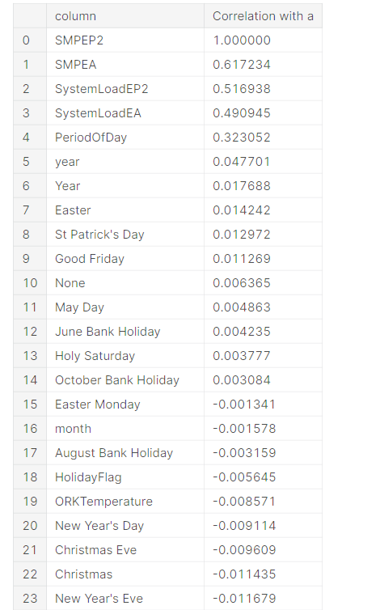

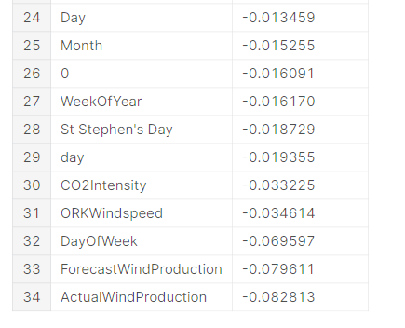

Program:

X2=df[["SMPEA","SystemLoadEP2","SystemLoadEA","PeriodOfDay",

"year","ActualWindProduction"]]

y2=df["SMPEP2"]

In [82]:

X_train2,X_test2,y_train2,y_test2=train_test_split(X2,y2,test_size=0.3,random_state=0)

In [83]:

rf2=RandomForestRegressor().fit(X_train2,y_train2)

In [85]:

rf2.score(X_train2,y_train2)

Out[85]:

0.9345853165856398

In [89]:

X3=df_remove_out.drop("SMPEP2",axis=1) *#bağımsızz değişkenler*

y3=df_remove_out["SMPEP2"] *# bağımlı değişkenler*

In [90]:

X_train3,X_test3,y_train3,y_test3=train_test_split(X3,y3,test_size=0.3,random_state=0)

In [91]:

rf3=RandomForestRegressor().fit(X_train3,y_train3)

In [92]:

rf3.score(X_train,y_train)

Output:

0.9525199962605772

Program:

from hyperopt import tpe,STATUS_OK,Trials,fmin,hp

from hyperopt.pyll.base import scope

unfold_moreShow hidden output

In [114]:

space={

"max_depth":hp.randint("max_depth",2,15),

"min_samples_split":hp.randint("min_samples_split",2,20),

"min_samples_leaf":hp.randint("min_samples_leaf",1,20),

"n_estimators":hp.randint("n_estimators",50,1000)

}

In [115]:

def hyperparameter_tuning(params):

clf=RandomForestRegressor(**params).fit(X_train,y_train)

acc=rf.score(X_train,y_train)

return acc

In [116]:

trials=Trials()

best=fmin(fn=hyperparameter_tuning,

space=space,

algo=tpe.suggest,max_evals=100,trials=trials

)

print("best:**{}**".format(best))

100%|██████████| 100/100 [1:53:52<00:00, 68.32s/trial, best loss: 0.9424727172628374]

best:{'max_depth': 12, 'min_samples_leaf': 2, 'min_samples_split': 8, 'n_estimators': 303}

In [117]:

best

Output:

{'max_depth': 12,

'min_samples_leaf': 2,

'min_samples_split': 8,

'n_estimators': 303}

Flowchart:

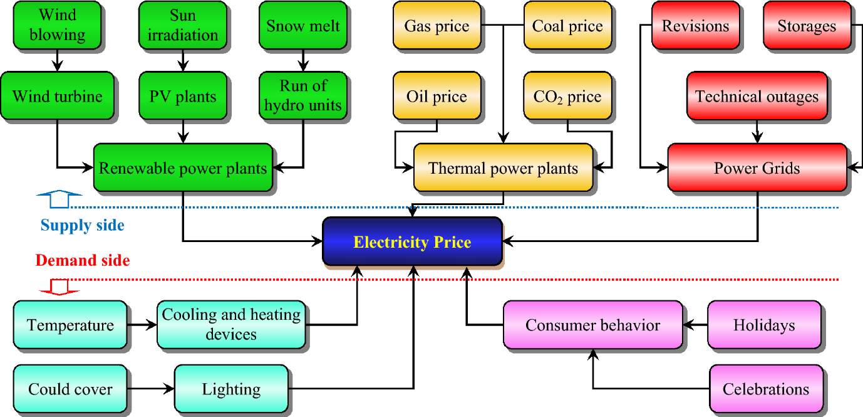

CONCLUSION

In this study, we tested various models for electricity price prediction and achieved high success rates...